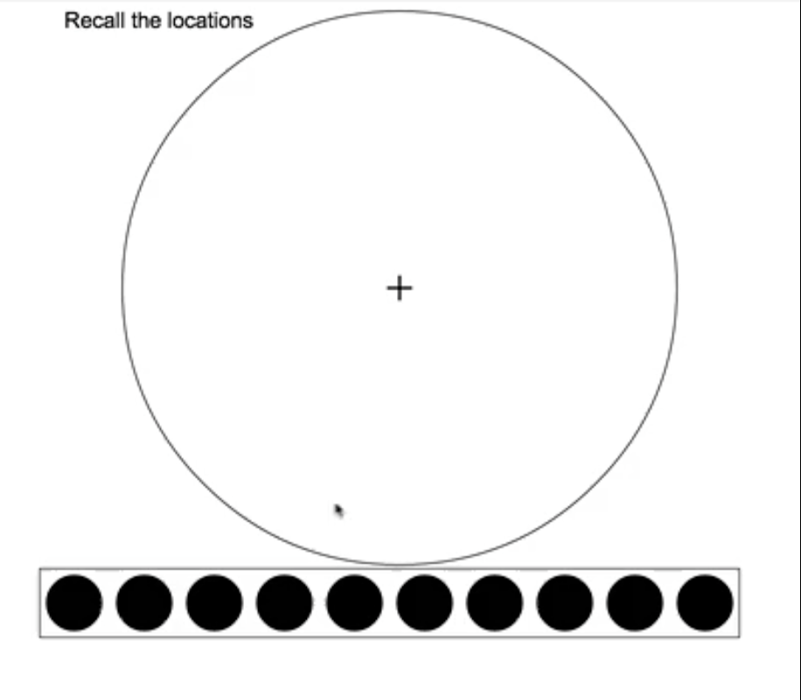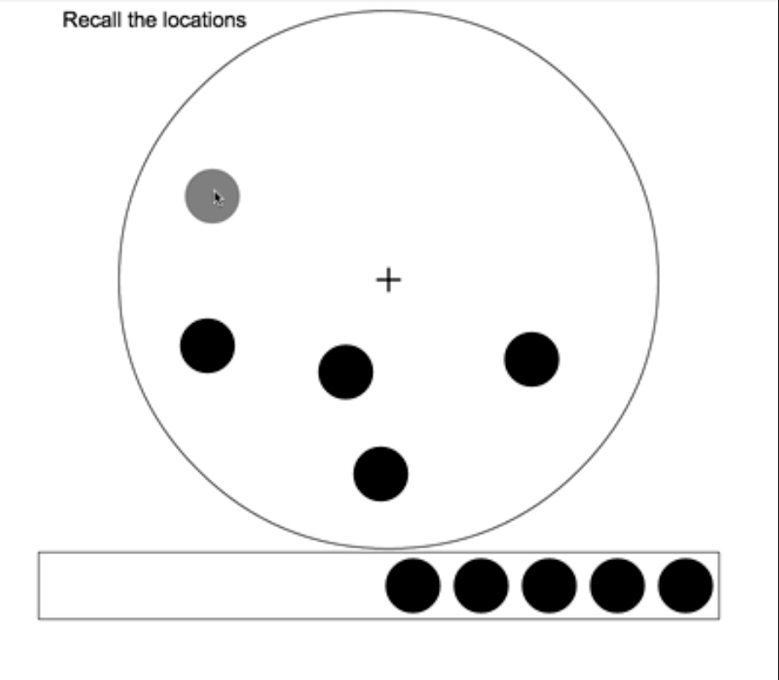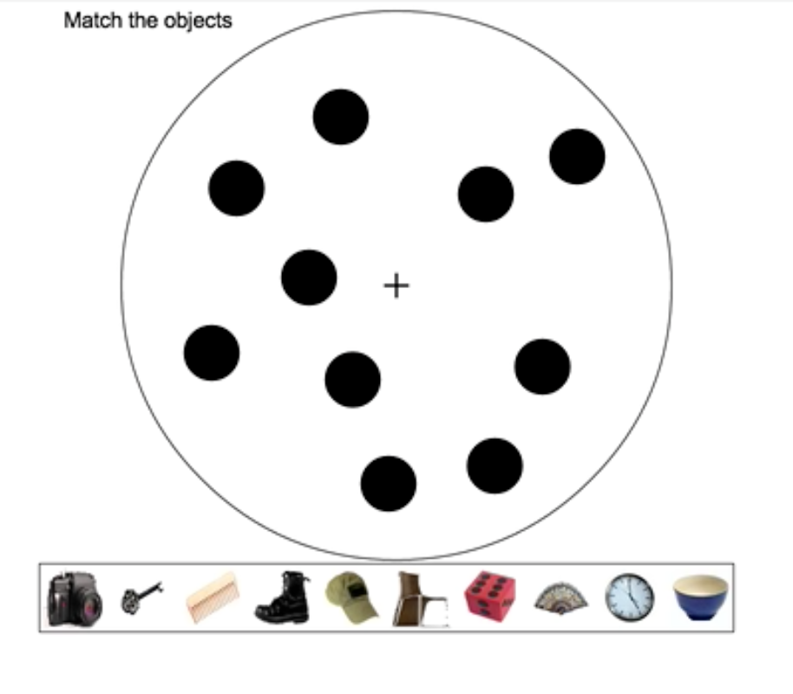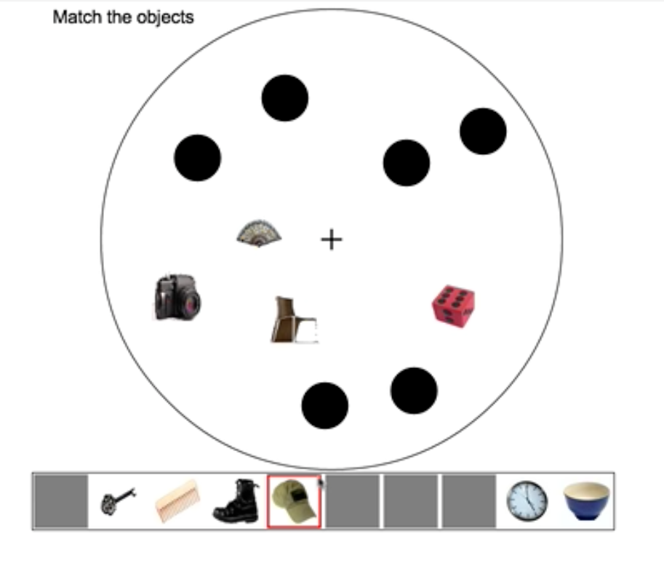
D
B
C
A
Figure 6. Example free recall trial from Experiment 3. (A) Subjects saw 10 black circles that would mark the locations of objects and (B) placed the circles wherever they recalled the location of an object. (C) Once subjects placed all ten circles, they saw all 10 objects in a random order and (D) matched the objects to the locations. Subjects had unlimited time to do the location recall and object matching phases and could rearrange the locations and object-to-location assignments as much as they wanted.

